**Name : P Neeraj Reddy**

**RegNo : 22BCB7156**

Code :

mkdir data

cd data

mkdir db0

mkdir db1

mkdir db2

"C:\Program Files\MongoDB\Server\8.0\bin\mongod.exe" --replSet myReplSet --dbpath C:\data\db0 --port 27019 --bind_ip localhost

"C:\Program Files\MongoDB\Server\8.0\bin\mongod.exe" --replSet myReplSet --dbpath C:\data\db0 --port 27020 --bind_ip localhost

"C:\Program Files\MongoDB\Server\8.0\bin\mongod.exe" --replSet myReplSet --dbpath C:\data\db0 --port 27021 --bind_ip localhost

Screenshots:

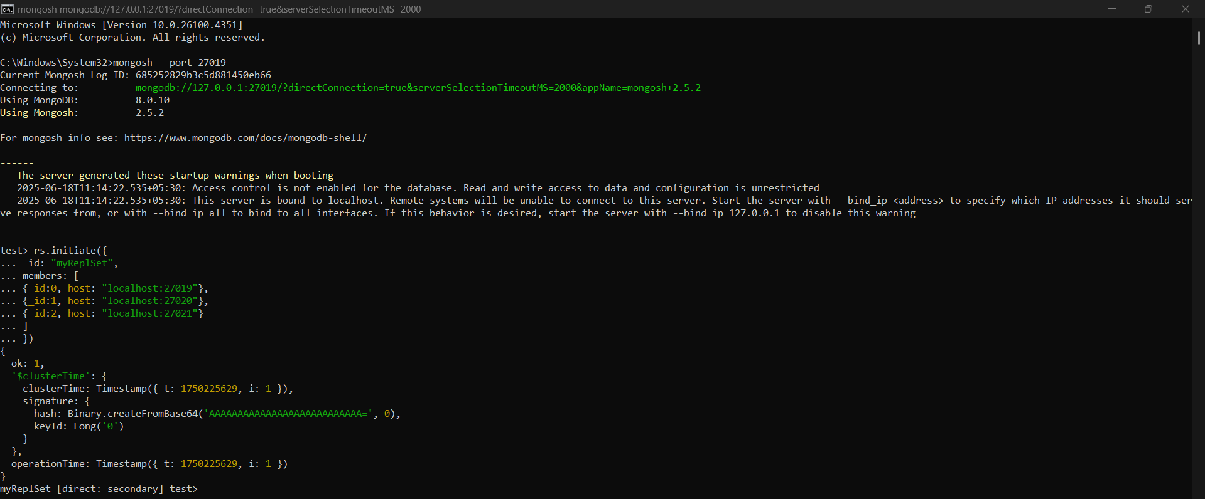

Primary Node :

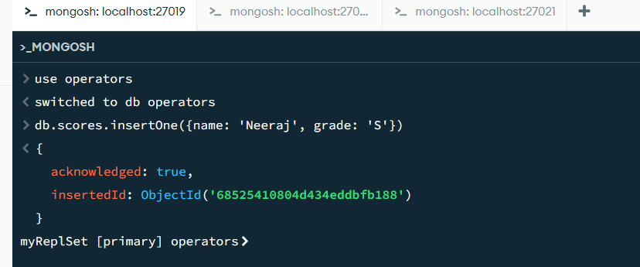

Seconday node1:

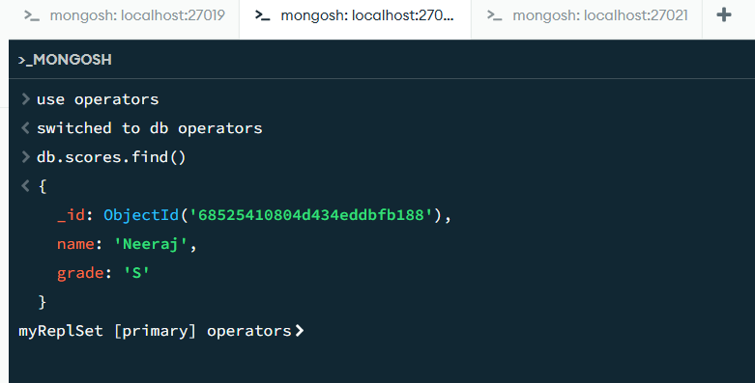

Secondary node2:

